**Create a Virtual Hard Disk and allocate the storage using VM ware workstation.**

**AIM:**

To Create a Virtual Hard Disk and allocate the storage using VM ware workstation.

**PROCEDURE:**

**STEP 1:**

First install VMware workstation in your pc/laptop. Then open already created any VM.

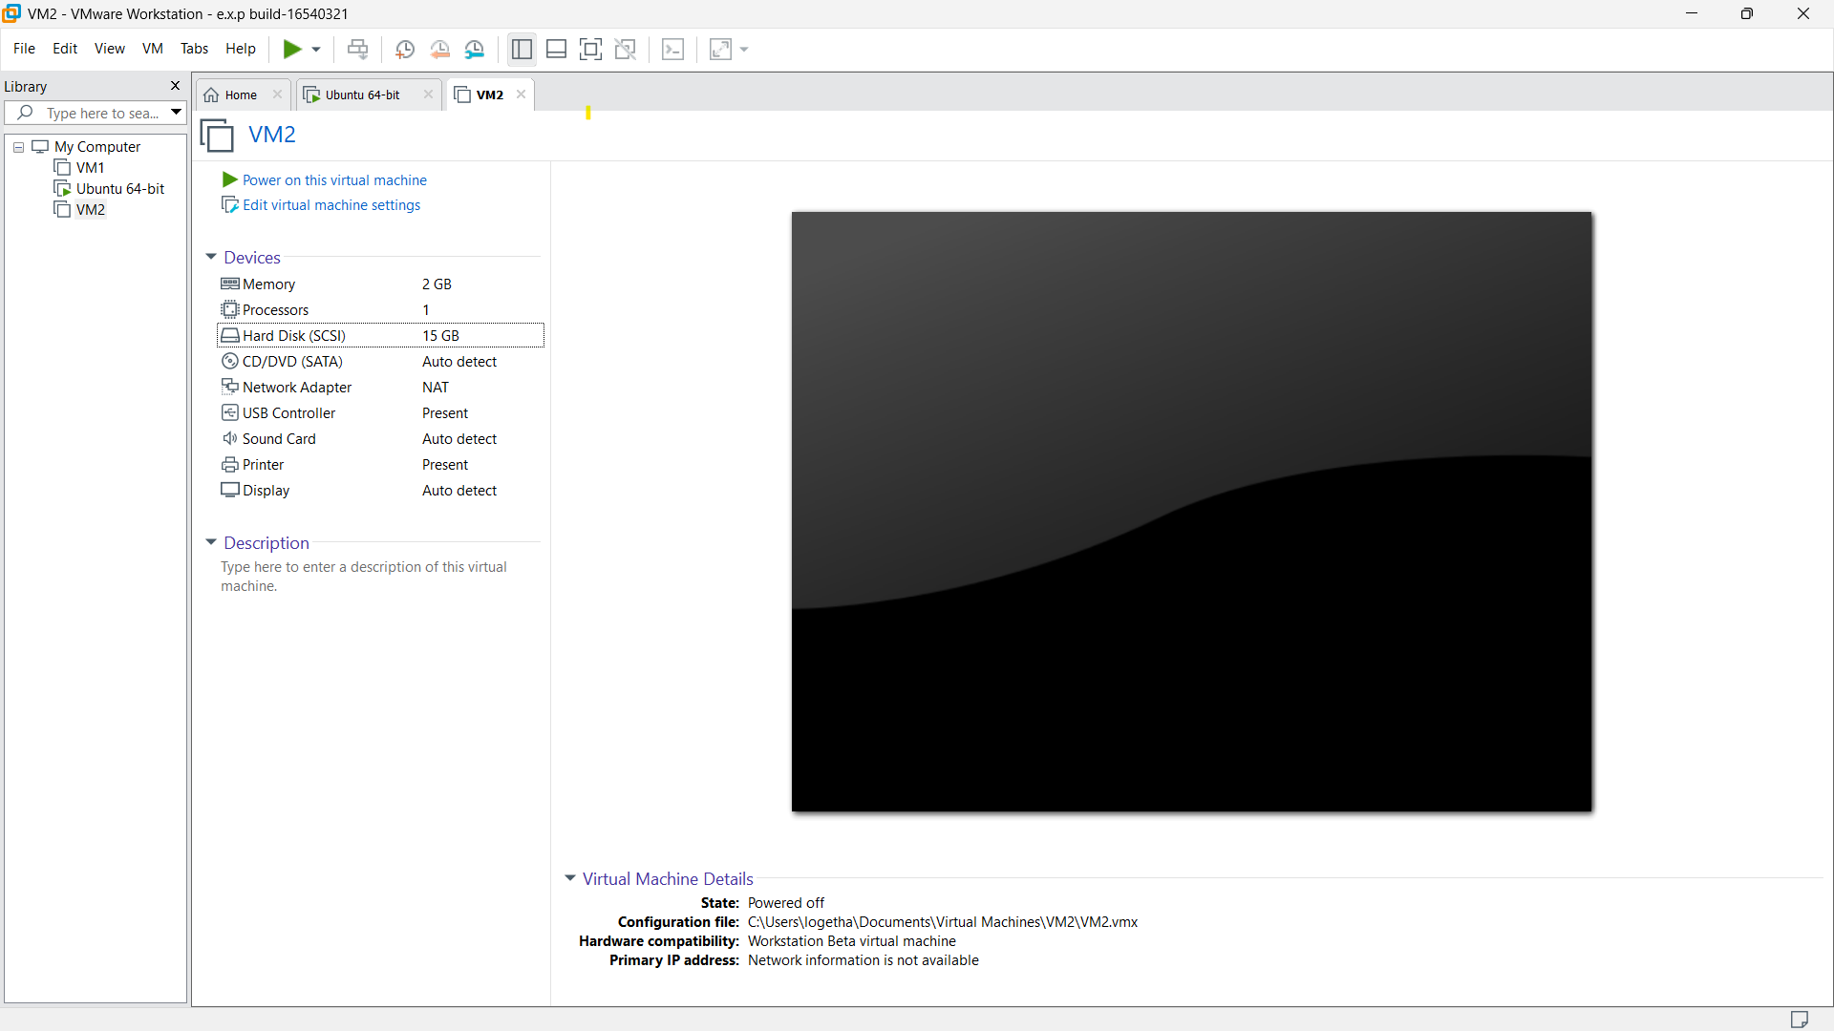

**STEP 2:**

Left side click any of the given specification. Then click Add option given below all the specification.

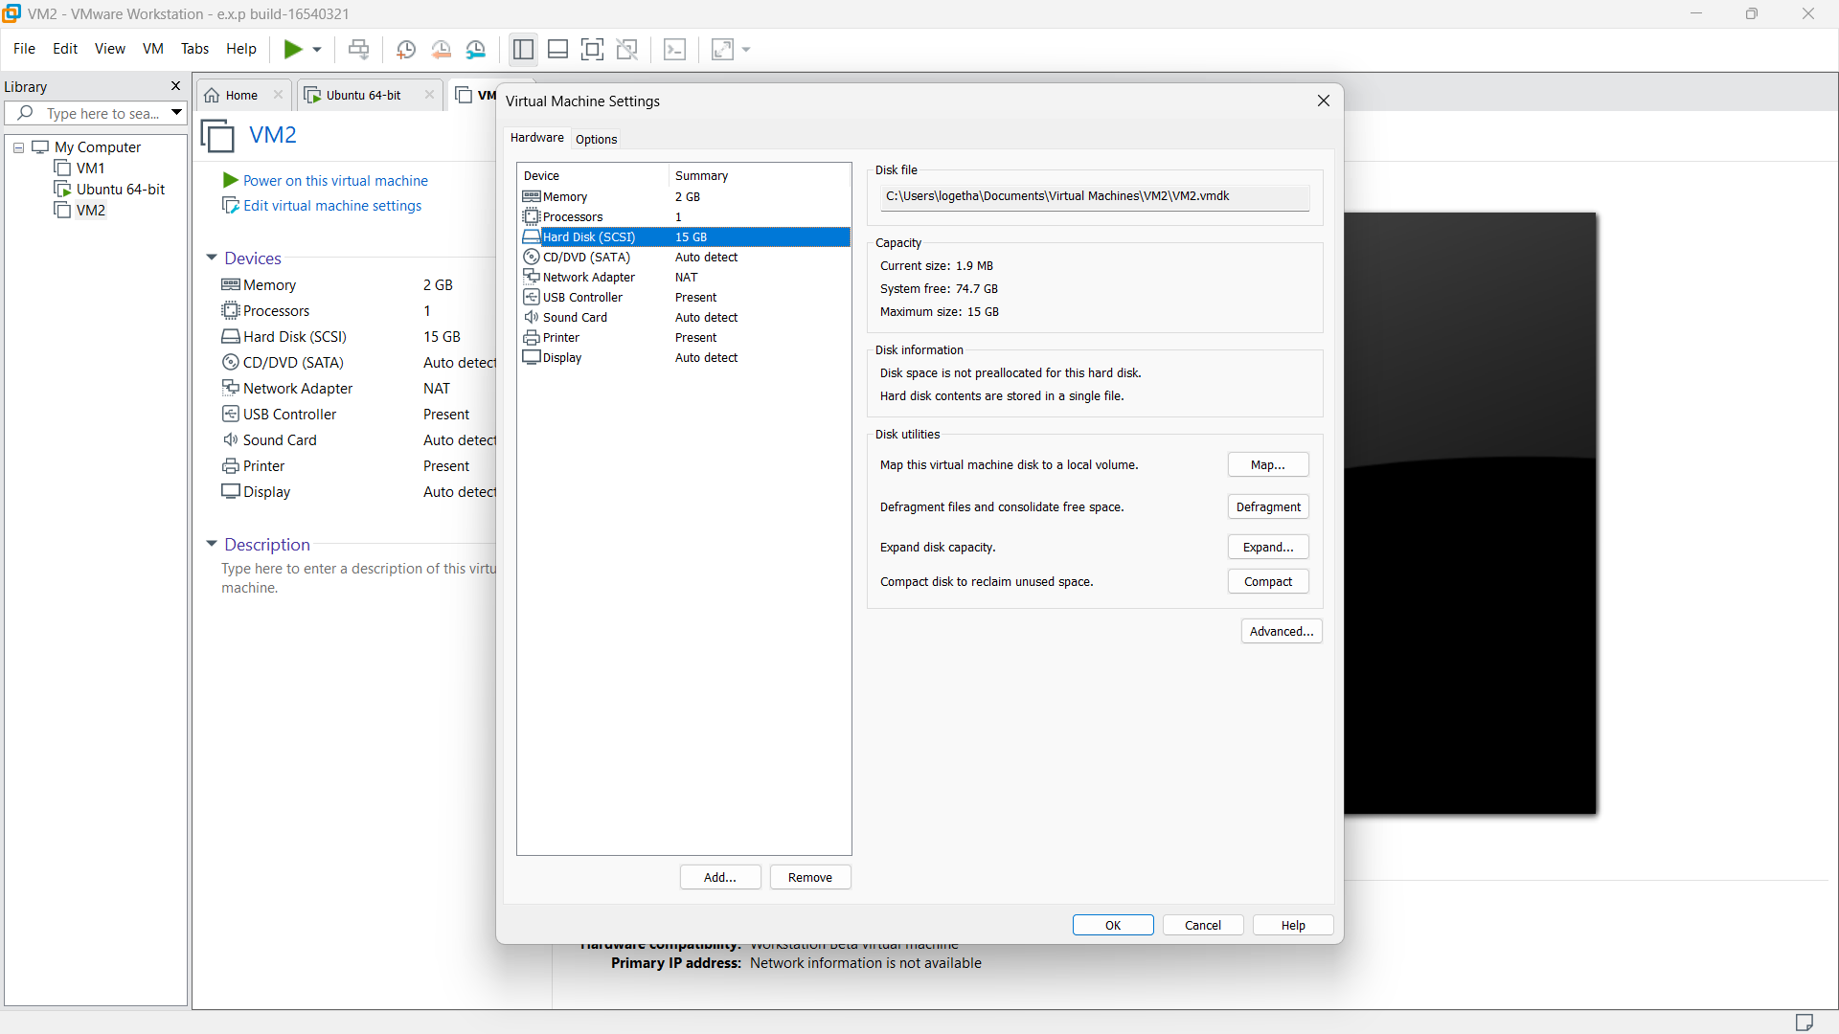

**STEP 3:**

Then click hard disk option,because we are going to Create a Virtual Hard Disk and allocate the storage using VM.

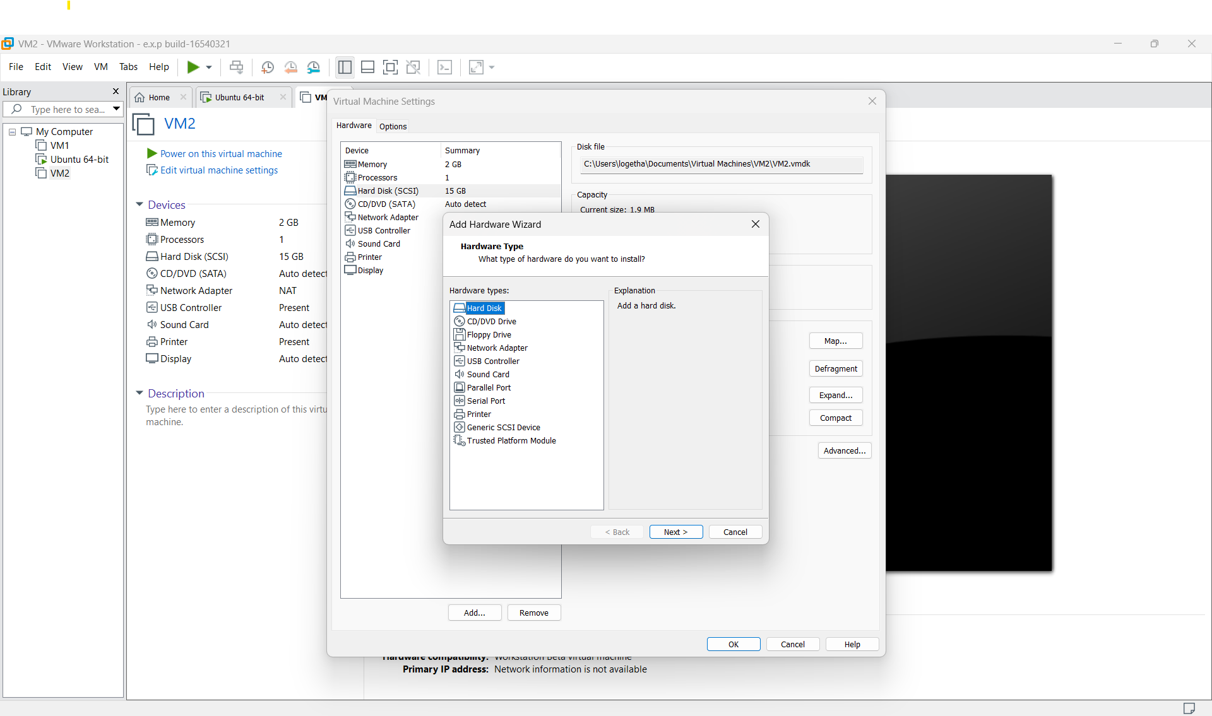

**STEP 4:**

And select SCSI option and click next.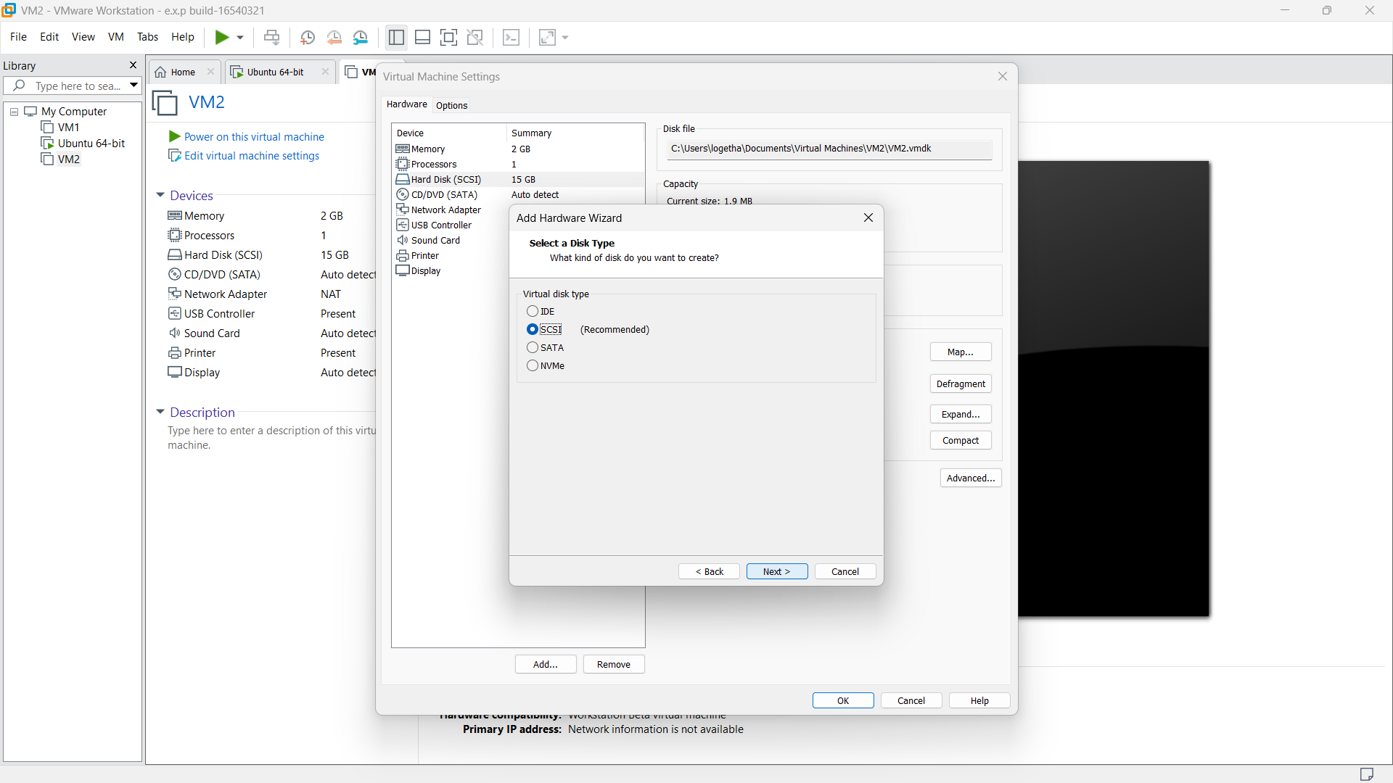

**STEP 5:**

then select first option from the displayed option.

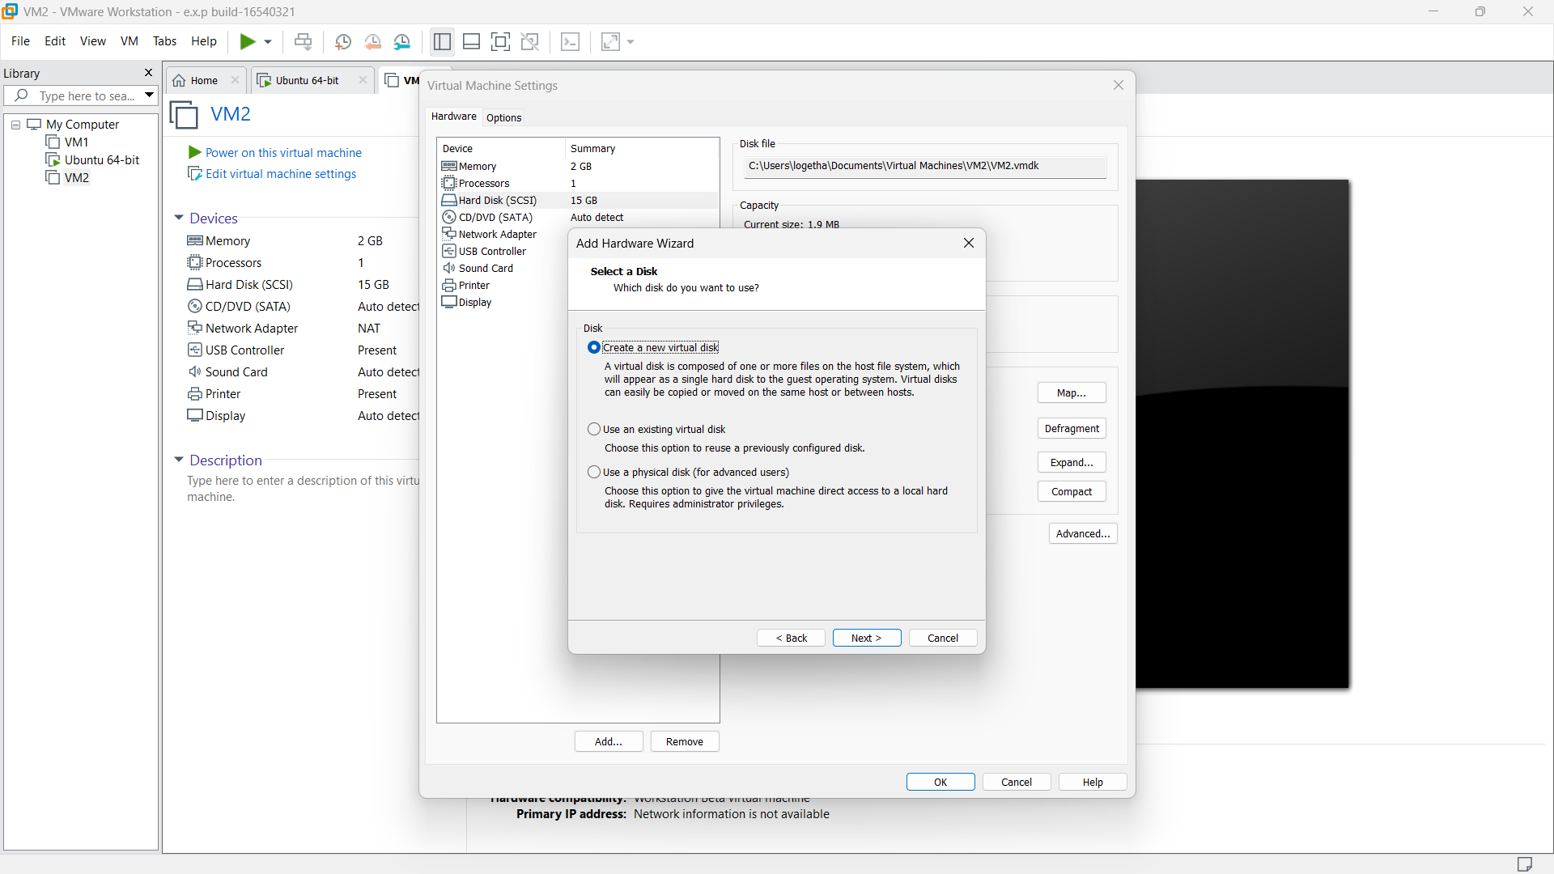

**STEP 6:**

then provide appropriate hard disk size.

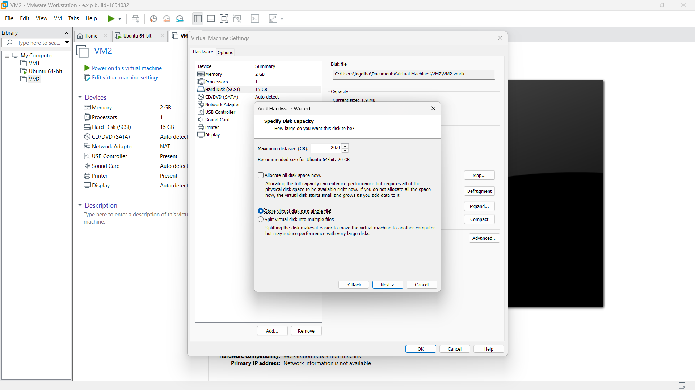

**STEP 7:**

Then give appropriate name for the specific disk.

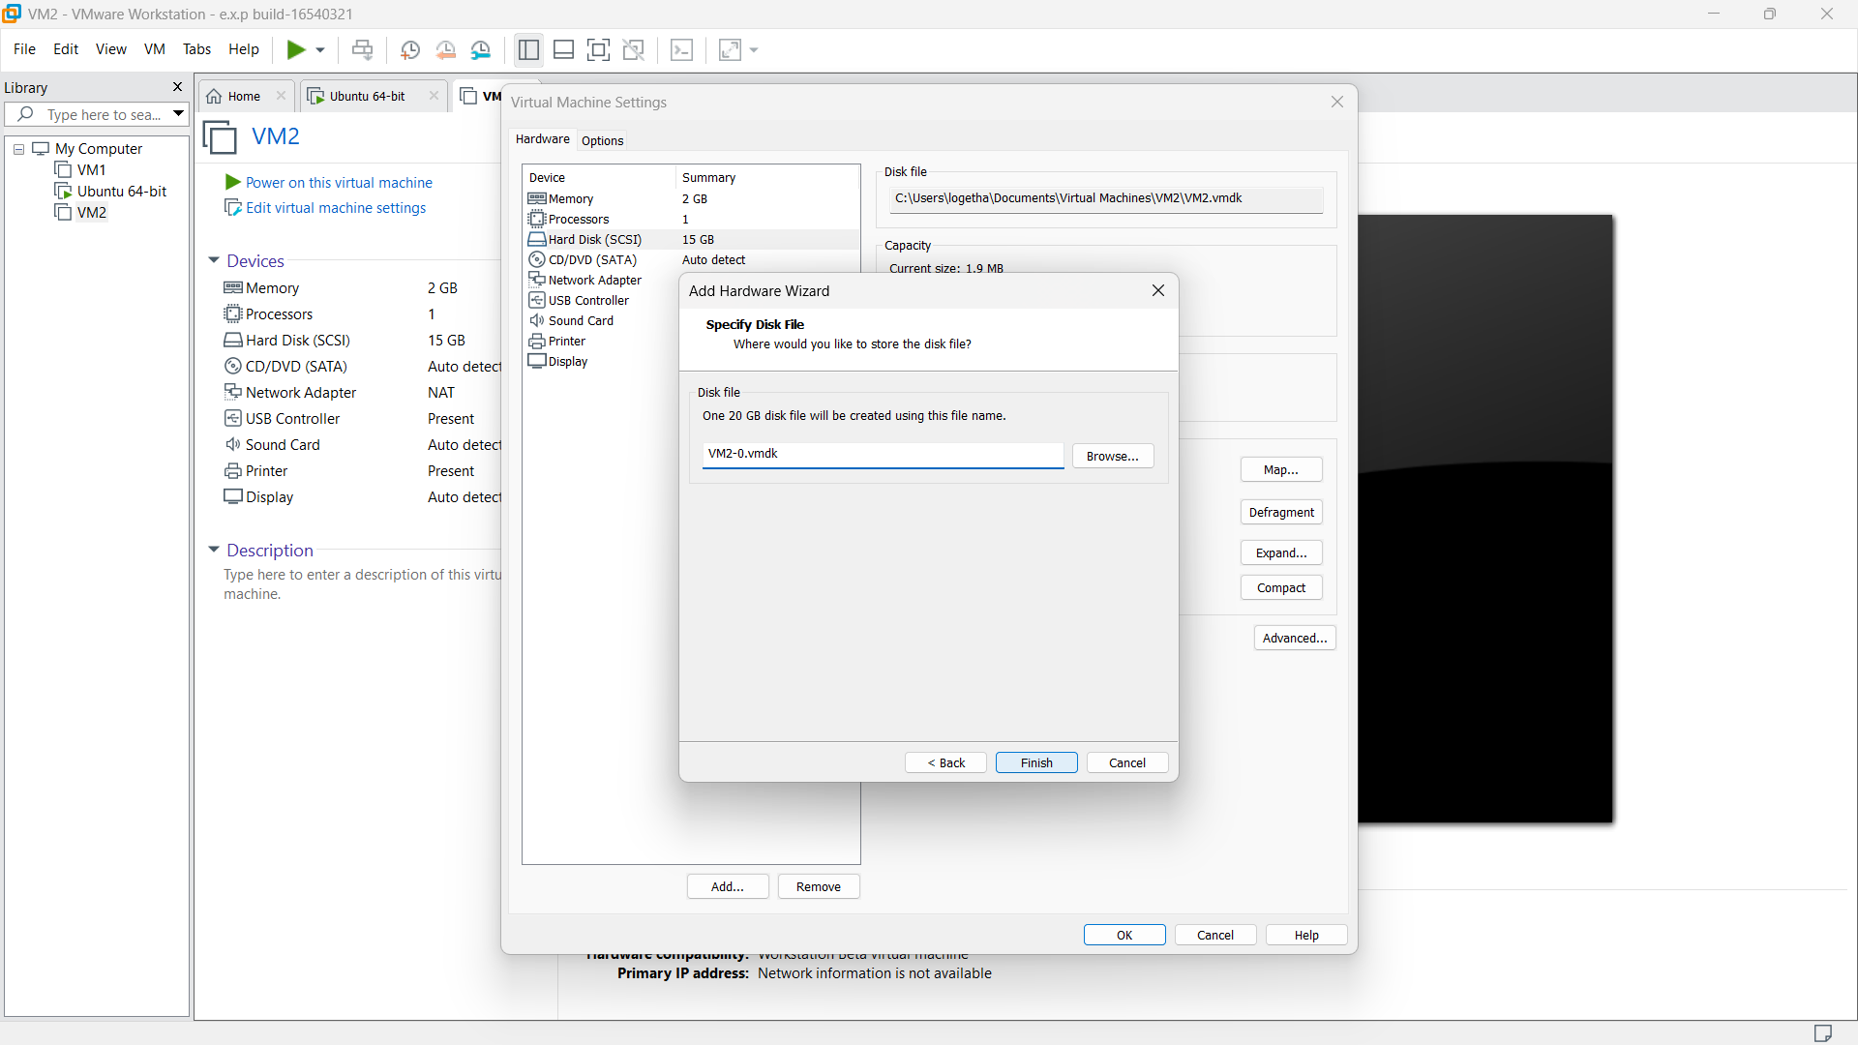

**STEP 8:**

Our VM was created a Virtual Hard Disk and allocated the storage using VM.

